**Ideation Phase**

**Brainstorm & Idea Prioritization**

|  |  |
| --- | --- |
| Date | 28 June 2025 |
| Team ID | LTVIP2025TMID35938 |
| Project Name | **Revolutionizing Liver Care : Predicting Liver Cirrhosis using Advanced Machine Learning Techniques** |
| Maximum Marks | 4 Marks |

**Brainstorm & Idea Prioritization:**

Liver cirrhosis is a chronic and progressive liver disease characterized by the irreversible scarring of liver tissue, which can lead to severe complications and liver failure if left untreated. This project aims to develop a predictive model for the early detection and prognosis of liver cirrhosis using machine learning techniques. The developed predictive model holds promise for early detection and prognosis of liver cirrhosis, enabling healthcare professionals to initiate timely interventions and personalized treatment strategies. By accurately identifying individuals at risk of cirrhosis, this research contributes to improved patient outcomes and the optimization of healthcare resources.

**Step-1: Team Gathering, Collaboration and Select the Problem Statement**

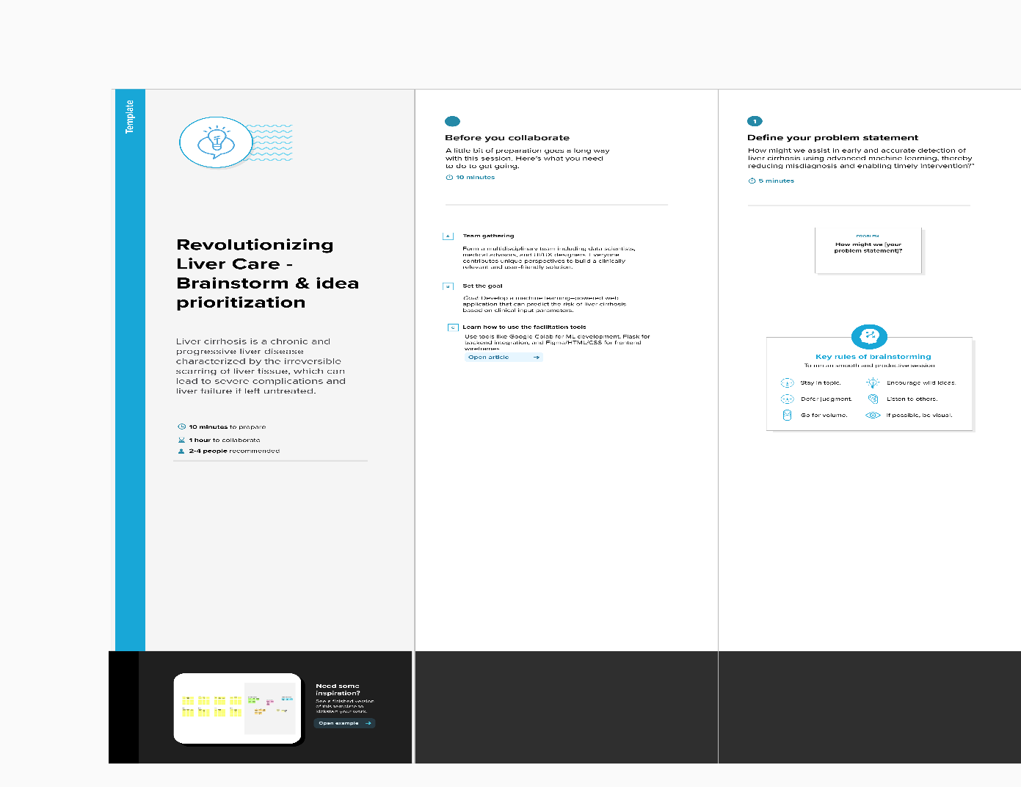

**Step-2: Brainstorm, Idea Listing and Grouping**

**📊 Data & Model Ideas**

* Use the UCI Liver Disorder/Cirrhosis Dataset
* Perform data cleaning, outlier removal, normalization
* Apply feature selection to improve model efficiency
* Train an XGBoost model and compare with Random Forest, SVM
* Evaluate using accuracy, F1-score, ROC-AUC

**👨‍⚕️ User-Oriented Features**

* Form to input values like:  
  *Bilirubin, Albumin, INR, Creatinine, Ascites, Encephalopathy, etc.*
* Display output:  
  *Prediction (Yes/No), Confidence Score, Risk Level (Low/Medium/High)*
* Visual output using badges, color codes, or charts

**Step-3: Idea Prioritization**

Using the XGBoost model with clinical features is given the highest priority because it provides high prediction accuracy and is widely used in healthcare-related ML tasks.

Building a multi-page Flask web application is also a high priority. It ensures the app is user-friendly, visually structured, and suitable for demo and deployment purposes.

Creating the prediction input form and displaying the output (including risk level and confidence score) is considered essential and thus a high-priority item. It forms the core interaction between the user and the model.

Including educational content on liver disease with visuals is marked as medium priority. It enhances user awareness and the overall value of the application but is not strictly necessary for the MVP (Minimum Viable Product).

